A
Project Report Titled
“Laptop Price Prediction”

Submitted to
Department of Data Science
of

Bunts Sangha’s
S. M. Shetty College of Science, Commerce and Management Studies
(Autonomous), Powai, Mumbai – 76

For Partial Fulfilment for Degree of
Bachelor of Science(Data Science)
2024-2025
In the subject head
Project (Semester V)
Submitted by
Ritu Ramsingh Chaurasia

Under the Guidance of
Asst. Prof. Himani Shukla
BUNTS SANGHA’S
S.M. SHETTY COLLEGE OF SCIENCE, COMMERCE &
MANAGEMENT STUDIES (AUTONOMOUS) , POWAI,
MUMBAI – 400076

“Laptop Price Prediction”

CLASS: T.Y.B.SC.D.S. (2024-25)
SEMESTER: V
SUBMITTED BY (NAME): RITU RAMSINGH CHAURASIA
SUBJECT : Project Dessertation
SEAT NUMBER: 7AR5002

SUBMITTED TO
DEPARTMENT OF DATA SCIENCE

Asst. Prof. Himani Shukla Dr. Tushar Sambhare
Project Guide Coordinator External Examiner

For Partial Fulfilment for Degree of
Bachelor of Science in DS (Data Science) in 2024-2025
THE APPROVAL PROJECT PROPOSAL
(Note: All entries of the proforma of approval should be filled up with
appropriate and complete information. Incomplete proforma of approval in any
respect will be summarily rejected.)

1.Name of the student:
Ritu Ramsingh Chaurasia
2.Title of the project
Laptop Price Prediction
3.Name of the Guide
Asst. Prof. Himani Shukla
4.Is this your first submission?
Yes.
Student Name: | Ritu Ramsingh Chaurasia
Student control ID: | 7AR5002
Student Roll No: | 02

ACKNOWLEDGEMENT
I am profoundly grateful to all who have been part of the journey that led to the successful completion of my project titled “Laptop Price Prediction.”
Firstly, I extend my heartfelt thanks to my esteemed guide, Prof. Himani Shukla, for their expert advice, unwavering support, and patience throughout the course of this project. Their mentorship has been invaluable in shaping this work.
I am also deeply thankful to Dr. Tushar Sambare, our coordinator, for their guidance and for ensuring that we had all the necessary tools and resources to complete this project smoothly.
My sincere appreciation goes to Dr. Sridhara Shetty, Principal of Bunts Sangha’s S. M. Shetty College of Science, Commerce, and Management Studies, for providing a platform that nurtures innovation and learning. Their leadership has inspired me to aim for excellence.
Lastly, I would want to express my gratitude to my family and friends for their love, encouragement, and support as they helped me get over the difficulties this endeavour presented.

DECLARATION
I hereby declare that the project entitled, “Laptop Price Prediction” done at the place where the project is done, has not been in any case duplicated to submit to any other university for the award of any degree. To the best of my knowledge other than me, no one has submitted to any other university.
The project is done in partial fulfilment of the requirements for the award of the degree of BACHELOR OF SCIENCE (DATA SCIENCE) to be submitted as a final semester project as part of our curriculum.

RITU RAMSINGH CAHURASIA
Name and Signature of the Student

ABSTRACT
The objective of the laptop price prediction project is to create a machine learning model that can reliably forecast laptop pricing depending on a range of parameters, which are important attributes. Obtaining a dataset from Flipkart, handling missing values, encoding categorical variables, and doing a thorough preprocessing step are all part of the project. Furthermore, during the modeling phase, data transformation and normalization techniques are used to guarantee that features on various scales are handled identically. These procedures help the project create a solid dataset that is suitable for machine learning model training.
All things considered, the project's conclusions offer insightful information on the variables affecting laptop costs. The findings can help producers identify important price drivers and customers make well-informed purchasing decisions. This study not only shows how machine learning techniques may be used to anticipate prices effectively, but it also emphasizes how crucial careful data preparation, visualization, and model evaluation are to producing accurate results.
This model which is going to be developed in this project which will give approximate price of the respective laptop based on the attributes which are provided by users.

INDEX

Sr.No. | Content | Page No.
 | Chapter 1: Project Overview | 1 & 4
1.1 | Project Title | 1
1.2 | Objective | 1
1.3 | Scope | 3
1.4 | Stakeholders | 4
 | Chapter 2: Data Description | 5 & 20
2.1 | Data Sources | 5
2.2 | Data Collection | 6
2.3 | Data Description | 9
2.4 | Data Cleaning and Preparation | 19
 | Chapter 3: Methodology | 21& 30
3.1 | Analytical Approach | 22
3.2 | Visualization Techniques | 25
3.3 | Design Principles | 28
3.4 | Flow chart | 30
 | Chapter 4: Visualization Results | 29 & 37
4.1 | Key Findings | 31
4.2 | Visualization Examples | 33
4.3 | Interpretation | 35
4.4 | Gantt Chart | 37
 | Chapter 5: Challenges and Limitations | 38 & 43
5.1 | Challenges Faced | 38
5.2 | Limitations | 41
 | Chapter 6: Future Work | 44 & 46
6.1 | Recommendations | 44
6.2 | Next Steps | 46

 | Chapter 7: References | 47 & 48
7.1 | Data Sources | 47
7.2 | Literature | 47
7.3 | Tools and Software | 48
 | Chapter 8: Appendices | 49 & 50
8.1 | Appendix A: Data Tables | 49
8.2 | Appendix B: Code | 50
8.3 | Appendix C: Glossary | 50

Chapter 1: Project Overview

1.1 Project Title
The project title is Laptop Price Predict.

1.2 Objective
- The main objective of this laptop price prediction project is to create a strong machine learning model that can predict laptop prices with approximate accuracy. The model will make use of a number of crucial components that are essential to the features and functionality of any laptop in order to do this.
- These features include the brand, which substantially influences pricing tactics and molds consumer perception, as established brands are often viewed as superior quality, leading to premium pricing. Another important feature that determines the laptop's computational power and effectiveness and has an immediate effect on performance for different applications is the CPU type.
- Furthermore, RAM capacity has an impact on multitasking skills and user experience, making it a crucial component of total device performance. Through the examination of these characteristics in conjunction with storage capacity, screen size, operating system, and CPU generation, the research seeks to offer a thorough grasp of how these factors interact to affect laptop costs in the tough market. The ultimate objective is to provide customers with precise pricing forecasts so they can make well-informed judgments about what to buy.
- If Time permits a recommendation system will also be builds that makes suggestions for laptops that fall into a price range which will given by the users.

Also objective to answer some questions. Below the questions are and need to answer:

1.Which variables most affect the cost of laptops?

The objective of this laptop price prediction project is to analyze and determine which specifications significantly influence laptop prices by thoroughly examining the dataset. A key focus will be to assess how various attributes, such as processor generation, RAM size, and brand, affect the overall pricing. For instance, we aim to investigate whether opting for a higher generation processor results in a notable price increase, reflecting advancements in technology and performance capabilities. Additionally, we will explore the impact of increased RAM on pricing, evaluating if additional memory correlates with a higher price due to enhanced multitasking abilities and improved user experience.

2. To what extent is a machine learning algorithm able to forecast laptop prices?

In order to create and evaluate a model that projects laptop costs according to a particular feature set, the project focuses on evaluating the degree to which the selected features affect price projection accuracy. This procedure entails looking at a number of variables to assess how they affect the model's ability to forecast the future, including brand, CPU type, RAM size, and storage capacity. The study aims to address concerns about the predictability and predicted accuracy of the model by methodically testing it using these properties. The evaluation's conclusions will shed light on any potential shortcomings and offer a clearer picture of the model's performance. In the end, this research seeks to guarantee that the price forecasts produced are accurate and useful in actual situations, so improving

3. How can people effectively locate computers that fit their budget?
Recommendation systems that use machine learning to filter and rank laptops based on both their technical characteristics and price points can help users choose computers that meet their budgets. Users can enter precise criteria such as CPU type, RAM size, storage capacity, and screen size in this system, along with their intended budget. After processing this data, the model finds the laptops that provide the best value in terms of both price and performance within the specified budget by comparing it to a sizable dataset of laptops that are currently on the market. In addition to saving consumers from having to sort through countless possibilities, this approach offers recommendations that are specifically catered to their requirements and limitations.
1.3 Scope

- The scope of laptop price prediction project focuses on utilizing machine learning to predict laptop prices based on various technical and brand-specific features.
- This project is designed to assist consumers and businesses in understanding pricing dynamics in the laptop market.
- A dataset with the crucial attributes which are needed to predict the price of laptops. These characteristics are essential for creating a price prediction model.
- web-scraped collection of laptop specifications from e-commerce platforms, are the main sources of data. In order to improve the analysis of the machine learning algorithms, Here used different approaches to preprocess the data.
- The target variable in the dataset is the price of the laptop, which is predicted based on all other attributes.
- A auto fill option is there in the project using which the the customer will able to find the price of laptop with suitable configuration.

1.4 Stakeholders
The main stakeholders in the context of this laptop price prediction project would be those who could potentially employ the predictive model, including data analysts, tech enthusiasts, or e-commerce platforms trying to identify patterns in pricing. Even though the study was created as a stand-alone investigation without direct involvement from outside stakeholders, anyone or any organization interested in using data to inform their sales or purchasing strategies could find value in its findings. The model's conclusions may help manufacturers discover competitive advantages, merchants optimize their pricing, and customers make well-informed purchasing decisions. These fictitious stakeholders, while not directly participating, demonstrate the project's outcomes' wider relevance in real-world situations.

Chapter 2: Data Description

2.1 Data Sources
- One of the largest e-commerce sites in India, Flipkart has a large selection of laptops from various brands, making it a perfect resource for our project. In-depth product details, cost information, and user reviews are all available on the internet and are helpful in determining customer preferences and market trends.
- Web scraping techniques are utilized in the data collecting process from Flipkart to facilitate the automated extraction of pertinent information, hence maintaining the dataset's comprehensiveness and currency.
- A thorough examination of pricing considerations is made possible by the platform's broad product listings, which provide a comprehensive dataset encompassing a range of brands, models, and combinations. Moreover, Flipkart refreshes its listings often, making it possible to record real-time price changes and special offers—a crucial component of precise pricing prediction.
- Furthermore, Flipkart's data collecting procedure complies with ethical standards and web scraping rules, guaranteeing that the data is collected in an ethical and sustainable manner. All things considered, Flipkart provides a strong foundation for the laptop price forecast study and is a dependable and dynamic source of data.
- data source for laptop price prediction project is Flipkart, which serves as the primary source of information on laptop specifications and pricing.
- One of the largest e-commerce sites in India, Flipkart here, used which provides the data for the laptop price forecast project.
- The information most likely consists of comprehensive laptop specs and costs that were gathered using Python web scraping. The particular features that come from Flipkart like Laptop Brand, Storage type, price and others.

2.2 Data Collection
- Methods of data collection

- Web scraping, or the automated extraction of data from the Flipkart website, is the main technique utilized to acquire data. Python packages like Beautiful Soup and Scrapy, which are skilled at navigating HTML structures and collecting pertinent data fields, make this procedure easier.
- Finding particular URLs that have the needed laptop listings is the first step in the web scraping procedure. Key information such as brand, CPU type, RAM size, storage capacity, screen size, operating system, processor generation, storage type, and price are extracted by parsing each listing. To gain additional understanding of customer mood and product performance, user reviews and ratings are also gathered.
- Python modules such as BeautifulSoup or Selenium can be used to browse Flipkart's website and retrieve pertinent data, including laptop specifications (brand, CPU type, RAM, etc.) and prices.
- The Requests library is often used in the data collecting process to issue HTTP requests and acquire the HTML content of the sites. This library makes it easy to retrieve online pages by offering a simple and intuitive interface for submitting several kinds of HTTP requests, including GET and POST.
- After obtaining the HTML content, it can be further processed to extract pertinent information. A smooth connection to the website is made possible by the Requests library, which also makes it possible to retrieve the most recent product listings and specifications needed for the laptop price prediction study.
- Python will be used to gather the laptop data from Flipkart, utilizing a number of potent modules made for data manipulation and web scraping. In order to discover and collect pertinent laptop information from Flipkart's dynamic web pages, web browsers can be automated with the help of the Web Driver Manager.
- Pandas is also used for data management and manipulation, which makes it possible to organize gathered data into DataFrames for simpler processing and analysis.
- Any dynamic content that needs to be interacted with, such CAPTCHA processing or loading further results, can be handled by Selenium.

- Frequency of data collection

- The plan's frequency of updating the information to reflect current prices and laptop availability on Flipkart determines how frequently data is collected.
- Utilizing tools like uipath or python library(schedule) to set up automated web scraping at regular intervals (e.g., daily, weekly, or monthly).
- By doing this, it is made sure that the model is trained using the most recent data, which takes into account price changes, sales, and new laptop models.
- In order to keep the dataset current and indicative of market trends, regular data collecting is crucial to the laptop price prediction project.
- For stakeholders looking for fast and accurate information for decision-making, regular updates improve the model's agility and enable it to react swiftly to changes in the market landscape.
- The research is able to obtain substantial amounts of data in an effective manner by using web scraping techniques and automated data gathering systems. This keeps the analysis current and complete.
- Accurate recording of seasonal pricing fluctuations, such as holiday sales, is ensured by regular data collection.(using python schedule library).
- Frequent data collection—daily or weekly intervals, for example—allows for the accounting of price variations brought on by sales occasions, promotions, or the introduction of new products. This method reduces the possibility of employing out-of-date data, which could distort the predictions made by the model.

- Tools and software used

- Python is the main programming language used for web scraping, data analysis, and prediction model construction. Which is going to be used in the project for various thing like to scrape data from flipkart, creating a model and also a GUI.
- Pandas is a Python data analysis and manipulation toolkit. It offers data structures that are necessary for working with structured data, such as DataFrames.
- Selenium: A web automation tool for data scraping from dynamic websites with JavaScript-loaded content. It accesses and retrieves data by mimicking browser operation.
- Streamlit: A framework for creating and implementing machine learning model web apps. It facilitates the development of an intuitive user interface for your laptop price prediction model. A User interface will me created using streamlit which will provide users to navigate in the wed app.
- Scikit-Learn: A Python machine learning library. It offers resources for machine learning techniques, such as regression models, as well as tools for model evaluation and training.
- Uipath: A tool for robotic process automation (RPA) that is being used to schedule jobs, execute Python scripts, and automate web scraping.
- Schedule library: this is a python library which is going to be used for regular srcaping the data form web page(Flipkart). (uipath or schedule out one will be used for this purpose).
- VS Code: a code editor for organizing project files, creating and editing Python scripts and other version control systems.

2.3 Data Description

The dataset used having 10 to 11 columns. this column (data) description is as follows:

Brand:
- the Brand column in the dataset used to estimate laptop prices and this contribute the most . the Brand column in the dataset used to estimate laptop prices. The names of several laptop companies, including Dell, HP, Lenovo, Acer, and Apple, are stored in this category variable.
- Every brand represents a specific degree of quality, pricing strategy, and market positioning; some brands are linked to expensive, premium computers, while others concentrate on models that are more reasonably priced.
- Each brand symbolizes a certain level of market positioning, quality, and pricing strategy, with some names being linked with high-end, premium laptops while others focus on affordable or budget-friendly products.
- Because pricing differences are frequently influenced by consumer perceptions, brand loyalty, and the perceived value of the brand, the brand feature has a major impact on laptop prices.
- For example Apple and Dell, for instance, are regarded as luxury brands and can fetch higher costs because of their reputation for excellence in design, innovation, and quality. On the other hand, companies like as Lenovo or Acer may provide better performance at more affordable prices.
- The dataset allows the model to take these variations into account and determine how brand identity affects laptop price by including the Brand column. This column functions as a key predictor in the model by assisting in the capture of an essential component of customer purchase behavior.
- This column is of string or object datatype. Hence it is a categorical column so it will be handled by using one-hot encoder during analysis.

Processor type:

- The type of processor that is installed in each laptop is represented by the Processor_Type column in the laptop price prediction dataset. This is an important factor that affects both the device's price and performance.
- The names of several processors are contained in this category variable, including AMD Ryzen 5, Intel Core i7, Intel Core i5, and Intel Celeron Dual.
- The laptop's processing power and efficiency are determined by the type of processor; in general, higher-end processors offer faster processing speeds, better multitasking capabilities, and superior performance in applications like software development, gaming, and video editing.
- One of the key factors influencing laptop prices is processor type: machines with high-end processors, such as AMD Ryzen 7 or Intel Core i7, tend to be more expensive than those with entry-level CPUs, such as Intel Celeron or Pentium.
- This column enables the predictive model to take into consideration differences in laptop performance and processing power. It also shows how manufacturers target distinct market segments, such as power users and budget customers, by positioning their goods according to processor capabilities.
- Processor_Type is included to help the model better grasp how particular hardware characteristics affect the laptop's overall worth.
- Flipkart product pages list a variety of processors (such as AMD Ryzen 7 and Intel Core i5). It is of a mixture if string and integer Datatype. hence this column will be treated as categorical column and will be handled using one-hoe encoder during analysis.

RAM Size:

- The quantity of Random Access Memory (RAM) that is available in each laptop is represented by the RAM_Size column in the laptop price prediction dataset. RAM is commonly measured in gigabytes (GB).
- RAM is a crucial component that directly affects how well a laptop performs, particularly when using memory-intensive apps and multitasking.
- Higher numbers, such 16 GB or 32 GB, found in high-performance or gaming laptops, are contrasted with lower amounts, like 4 GB, which are typical in entry-level or budget-friendly computers.
- The amount of RAM in a laptop is a major factor in deciding its cost; laptops with more RAM capacity are typically more expensive since they can run demanding software smoothly and do more tasks at once.
- The predictive model depends on this column to assist capture the relationship between memory capacity and price, which enables the algorithm to modify forecasts according to the performance level that each laptop offers.

Storage Capacity:

- The entire internal storage capacity of each laptop is shown in the Storage_Capacity column of the laptop price prediction dataset.
- storage capacity is commonly expressed in gigabytes (GB) or terabytes (TB). Values like 256 GB, 512 GB, 1 TB, and 2 TB are displayed in this column to represent the capacities of the hard drive or solid-state drive (SSD) that houses the operating system, apps, and data on the laptop.
- A laptop's storage capacity has a significant impact on its price because it enables customers to store more media, applications, and files without requiring additional devices.
- Variations in the sizes and types of storage (e.g., 1 TB , 256 GB ). It is of a mixture if string and integer Datatype. However in further analysis this column is converted into fully integer Datatype by converting the TB into GB.

Storage type:

- The type of storage technology used in each laptop is represented by the Storage_Type column in the laptop price prediction dataset. This technology has a substantial impact on both price and performance.
- Types including HDD (hard disk drive), SSD (solid state drive), and hybrid storage alternatives are usually included in this category variable. Traditional mechanical HDD drives are more affordable and have bigger storage capacities than SSDs, but they typically have slower data access times.
- On the other side, SSDs offer quicker file transfers, quicker startup times, and better general system responsiveness, which is why more and more current laptops—especially those targeted at performance-oriented users—are using them.
- Customers seeking a flexible alternative may find hybrid storage systems appealing as they offer a balance between speed and capacity by combining SSD and HDD technology.
- For the prediction model to effectively capture the variations in cost linked to different storage technologies, the Storage_Type column is crucial. Due to their superior performance advantages, laptops with SSDs are usually more expensive than those with HDDs, but the latter may be more affordable.
- The Storage_Type attribute helps the model better grasp how storage technology affects the total cost of laptops, which enables it to make more precise forecasts depending on the needs and preferences of users.
- This column is of string or object datatype. Hence it is a categorical column so it will be handled by using one-hot encoder.

Screen Size:

- The physical size of the laptop's display, usually expressed in inches, is represented by the Screen_Size column in the dataset used to predict laptop prices.
- This number element represents the diagonal measurement of the screen with values such as 13.3 inches, 15.6 inches, 17 inches, and so on.
- The size of the laptop's screen has a significant impact on its cost because higher-quality screens typically come with a higher price tag because of the added materials and better viewing experience they offer.
- 13.3-inch screens are typically found on thin, lightweight laptops that are meant for people who value portability above all else, and they are frequently more reasonably priced.
- However, laptops with larger screens—such as 15.6 or 17 inches—are usually targeted at consumers who want a more immersive visual experience, including graphic designers, video editors, or gamers.
- The dimensions of a laptop's display, such as 13.3 or 15.6 inches. It is of Integer Datatype we can also say as It is a numerical datatype. This will be as it is when using for analysis.

Operating System:

- The software platform that is installed on every laptop and is responsible for managing hardware resources and providing an interface is represented by the Operating_System column in the dataset that predicts laptop prices.
- Operating systems such as Windows 10, Windows 11, macOS, Linux, or any other OS are included in this category; they are all tailored to meet the needs and tastes of individual users.
- The operating system has a big impact on the cost of the laptop. High-end models, like those made by Apple, usually come with expensive operating systems like macOS, although a wide range of models, from entry-level to high-end, frequently come with Windows and Chrome OS.
- This column in the dataset having a mixture of string and integer Datatype. Hence it is a categorical column so it will be handled by using one-hot encoder.

Processor Generation:

- The laptop pricing forecast dataset's Processor_Generation column shows the generation of processors that are installed in each laptop, providing insight into the CPU's capabilities and technical improvements.
- This numerical feature, which represents the constant advancements in processor design, speed, and efficiency with each new generation, usually contains figures like 8th Gen, 10th Gen, 11th Gen, and 12th Gen.
- The performance, energy efficiency, and innovative features of the latest generations typically translate into higher laptop prices.
- The increased processing power that laptops with subsequent CPU generations—such the 11th or 12th Gen—offer makes them more expensive overall because it's necessary for activities like gaming, video editing, and intensive multitasking.
- However, laptops from earlier generations, such as the 7th or 8th Gen, are still appropriate for basic computing needs and are typically less expensive.
- The relationship between pricing and technology improvements is captured by the Processor_Generation column, which is an essential component of the predictive model.
- Because newer generations offer substantial performance improvements, the model can anticipate customer willingness to pay for cutting-edge technology and how earlier generations impact the total cost of the laptop by including them in the dataset.
- Variations in this column (e.g., 10th Gen, 11th Gen). It is a mixture if string and integer Datatype. However in further analysis this column is converted into fully integer by removing the strings.

Prices:
- The monetary value or cost of each laptop is represented in the Prices column of the laptop price prediction dataset. This value is usually expressed in the Indian currency i.e. Rs
- The selling price of laptops is represented by the numerical figures in this column. That why this column is of Integer(numerical) Datatype.
- These prices vary depending on a number of parametersor features (which are listed above).
- Both exterior market factors (like brand reputation and demand) and internal laptop components (like processor and RAM) have an impact on this column.
- Higher costs are typically connected to premium brands, potent hardware, and cutting-edge features, whilst lower costs are connected to more affordable versions with more basic features.
- The value that the machine learning system seeks to forecast based on the specifications of the laptop is the Prices column, which is the target variable in the prediction model.
- Being the dependent variable that enables the algorithm to determine how various laptop features affect the total cost, the Prices column is essential to the prediction model.
- Through an understanding of the relationships between the target (prices) and the numerous predictors (brand, processor type), the model is able to deliver precise price predictions for laptops with particular configurations.

Reviews:
- The Reviews column in the laptop price prediction dataset represents the number of customer reviews that a particular laptop has received on the e-commerce platform. It provides insights into the popularity and customer engagement with a specific laptop model.
- A higher number of reviews often indicates a well-known or frequently purchased laptop, whereas laptops with fewer reviews may be newer models or less popular among buyers.
- Customer reviews can indirectly reflect the quality and reliability of a laptop, as models with a significant number of positive reviews tend to have better user satisfaction and demand.
- While the Reviews column is not a direct determinant of price, it can help understand market trends and consumer preferences, potentially influencing pricing strategies.
- This column is of a mixed datatype (string and integer) initially, as some entries might contain missing or improperly formatted values. For accurate analysis, it is converted into a fully integer datatype, ensuring consistency for potential statistical or trend analysis.
urls:
- The URL column in the laptop price prediction dataset contains the web link to the specific product listing from which the data was scraped. This URL serves as a reference to the original source of the laptop details.
- On the e-commerce website, it allows users to examine more information like customer reviews and ratings, confirm product specifications, and view updated prices.
- Each laptop entry is identified by its URL, which enables real-time pricing tracking, comparison, and data confirmation in the future.
- The URL itself can be helpful for incorporating features like real-time price updates or guiding users to buy the suggested laptop, even though it has no direct impact on the prediction model.
- The datatype of this column is string, as URLs are text-based links. It is not changed during preprocessing as it does not help to numerical model training but is preserved for data tracking and user navigation purposes.
Column Name | Description
Review | Number of customer reviews, indicating popularity and user feedback.
Brand | The manufacturer of the laptop (e.g., Dell, HP, Lenovo) which affects quality, support, and reputation.
Processor Type | Determines the laptop’s performance; includes Intel (i3, i5, i7, i9) and AMD (Ryzen 3, 5, 7, 9).
RAM Size | Defines multitasking capability; more RAM improves speed and responsiveness for heavy tasks.
Storage Capacity | The amount of data the laptop can hold; larger capacity allows for more files, software, and media.
Storage Type | Can be HDD (slower, cheaper) or SSD (faster, more efficient); affects speed and performance.
Screen Size | Measured in inches; larger screens are better for productivity, while smaller ones improve portability.
Operating System | Software managing hardware and applications (e.g., Windows, macOS, Linux); impacts compatibility.
Processor Generation | Indicates the latest advancements in CPU technology; newer generations provide better performance and efficiency.
Price | The cost of the laptop, varying based on specifications, brand, and features.
URL | Direct link to the laptop's product page, allowing users to verify specifications and check current prices.

2.4 Data Cleaning and preparation

- Handling missing values
- In order to guarantee the precision and dependability of the laptop price prediction model, handling missing values was an essential step in the data preprocessing phase. In laptop dataset the data is first analyse the dataset wheather theres is any missing values present or not.
- This missing values is seen by using python code and python visualization i.e. heatmap if any missing value present in the dataset the heatmap will show the bar for that. In the the laptop dataset there is a numerical columns and categorical columns to fill missing value in both column different approach used.
Numerical columns:
- In order to accommodate missing values, the overall mean or mode of the corresponding column is used in their place. This strategy ensures that the integrity of the dataset is maintained while reducing the impact of missing data on the study.
- For example, in the laptop dataset's Review column, substituting the mean review score for absent values preserves the statistical features of the data and makes predictions and insights more accurate.
- We can lessen the bias that could result from just eliminating rows with missing values, which could result in a substantial loss of data, by utilizing the mean instead. When working with huge datasets, this imputation method is especially helpful because it preserves the dataset's size and offers an acceptable.
Categorical columns:
- missing values are handled by labeling them as unknown or replacing them with 0. For instance, missing values in the column that provides information on the operating system that is installed on the laptops may mean that the particular operating system data is not available.
- We can signal that the laptops do not have the specified operating system by replacing these missing numbers with 0. Using unknown clearly denotes a lack of information rather than an assumption about the product's characteristics.
- This approach is especially good at preserving the integrity of the dataset because it closes any gaps that can cause problems during analysis or result in incorrect predictions. Furthermore, this method of populating category columns permits.
- Data transformation or normalization

- Data transformation and normalization were necessary steps in the laptop price prediction project to get the dataset ready for the best possible model performance. To make sure that every feature is compatible and can be handled by machine learning algorithms efficiently, data transformation is essential.
- The dataset in this case was normalized, especially because it contained variables with different scales. For example, the RAM_Size was measured in gigabytes (GB), whereas the Screen_Size was represented in inches.
- Because of this difference in measurement units, there may be circumstances in which some features have an excessive impact on the model just because of their size, which could distort the findings.
- Normalization was carried out to solve this problem by scaling the characteristics to a standard range, usually between 0 and 1. This procedure makes sure that no single characteristic controls the learning process of the model, resulting in a more accurate and balanced forecast.
- Additionally, it was required to convert columns that had mixed data types into completely numerical columns in order to further improve the consistency of the dataset. For example, the initial values in the RAM_Size column included both string and numerical components, such as "6 GB," "8 GB," etc. there are many other cloumns also which is needed to normalized as same.
- We converted the column into a purely numerical format by eliminating the text data (in this case, the "GB" suffix) and keeping only the numerical portion. This modification not only makes the data simpler, but it also removes any uncertainty regarding data types so that machine learning models can interpret the data.
- By preserving the dataset's integrity, it makes calculations run more smoothly and enhances the model's capacity to learn from the data. All things considered, these methods of data transformation and normalization were essential for efficiently preparing the dataset, guaranteeing that each feature made an equal contribution to the prediction job, and improving the model's overall performance.

- Merging or splitting datasets

- In order to organize the data for efficient modeling and analysis, splitting and merging datasets was an essential step in the laptop price prediction research. When creating an extensive dataset from several sources, merging datasets is frequently necessary since it enables the integration of varied data that might improve the study.
- But for this specific project, I decided to remove several columns that weren't required for model construction in favor of dropping data from other sources. This method improved the overall quality of the data used for prediction by ensuring that the final dataset contained only pertinent features, such as user reviews, pricing details, and comprehensive laptop specifications.
- However, dividing the dataset is an essential first step in getting ready for training and assessing the model. The data was separated into four separate sections for the purpose of predicting laptop prices: X_train, X_test, y_train, and y_test.
- This separation is crucial because it enables the model to be tested on one subset of data and learn from it on another, assisting in the evaluation of the model's accuracy and performance.
- The characteristics or independent variables used to predict laptop prices are contained in the X_train and X_test sets, whereas the target variable the actual laptop pricing is represented by the y_train and y_test sets.
- Usually, the dataset is split into two halves, one bigger for training and one smaller for testing, according to a predetermined ratio. This strategy makes sure the model has enough data to learn from, which is essential to enhancing its prediction power.
- As an example, it's standard procedure to set aside 60–70% of the data for training and the remaining 20–30% for testing. To discover the underlying patterns and connections between the features and the target variable, the model makes use of X_train and y_train.
- The X_test and y_test sets are used to assess the model's performance after training, enabling a comparison between the anticipated and actual prices to ascertain the model's accuracy in predicting unknown data.

Chapter 3: Methodology

  - Analytical Approach

- Statistical approach

- To efficiently model and evaluate the data for the Laptop Price Prediction Project, a variety of statistical techniques were utilized. The essential aspects of the data were summarized using descriptive statistics, and regression analysis was used to determine connections between laptop pricing and features.
- Using these techniques, we were able to identify underlying patterns in the dataset that provide light on the ways in which certain variables affect laptop prices. Furthermore, we want to improve our capacity to more accurately forecast future price scenarios through the application of statistical approaches, enabling us to make better-informed decisions.
- this will investigation contributed to our growing awareness of the different aspects that affect laptop prices and laid a strong basis for accurate pricing prediction and market research.
- The central tendency and distribution of numerical parameters, such as RAM_Size and Screen_Size_Inches, were initially assessed through descriptive statistics, which included calculating the mean, median, and standard deviation.
- These metrics provided insights into the average values and the overall spread of the data, allowing us to understand how these features vary across the dataset. By summarizing these numerical parameters, we were able to identify patterns and anomalies that could influence laptop pricing and inform subsequent analysis and modeling decisions.
- In order to make the model predict good, validation score is used and in future or when progress in the project other statistical method will also be used.

- Algorithm or method applied

- A range of machine learning models were assessed as part of the Laptop Price Prediction Project in order to determine the best method for precise price prediction.
- This models like (linear Regression, Random Forest , and other ) one model will be selected based on the performance.
- We attempted to identify the top-performing model that offers the highest predicted accuracy or a model which will predict approximately accurate Price .
- Methodically analyzing the performance of different models using measures like Mean Absolute Error (MAE) and R-squared.
- A supervised learning approach will be used as the data which collected is having labelled data or columns (such as brand, processor kind, and RAM size,prices). Because it uses the relationships between the input features and their corresponding labels to train the model, this method is especially good at predicting results.
- In order to optimize the accuracy and generalization of the model, methods like hyperparameter tweaking will be used to further improve its performance. Furthermore, cross-validation will be applied to guarantee that the model's performance is resilient and does not excessively depend on any one subset of the data.
- Our goal is to reduce the likelihood of overfitting by methodically modifying the hyperparameters and evaluating the model on various data splits.

- Tools and software used

- Several tools and software were used for the Laptop Price Prediction Project in order to expedite data processing, modeling, and deployment. Python was the main programming language utilized, together with important libraries like Matplotlib and Seaborn for data visualization and exploratory data analysis, and Pandas and NumPy for data cleaning and manipulation.
- Pipeline was implemented for efficient processing, transformations were applied, and machine learning models were constructed using Scikit-Learn. The two main IDEs for development and execution were Google Colab and VS Code, which offered an interactive environment for debugging and code execution.
- Streamlit, a Python-based framework for building user-friendly web applications, was used for deployment, enabling a GUI for estimating laptop prices and making recommendations depending on user input.

3.2 VisualizationTechniques

bar chart
- Bar charts were a useful tool for visualizing the distribution and frequency of categorical data, giving a clear and understandable depiction of the different categories in the dataset. These charts make it possible to quickly evaluate the most popular features such as brand, operating system, and processor type by showing the counts of each category.
- The frequency of each category is shown visually, and it also makes it easier to grasp how these categorical characteristics connect to laptop costs. Additionally, by examining these bar charts, trends and patterns can be found, indicating which categories might have a bigger influence on price.
- All things considered, bar charts are an effective means of rapidly extracting important information from categorical data, supporting data-driven choices regarding laptop prices.
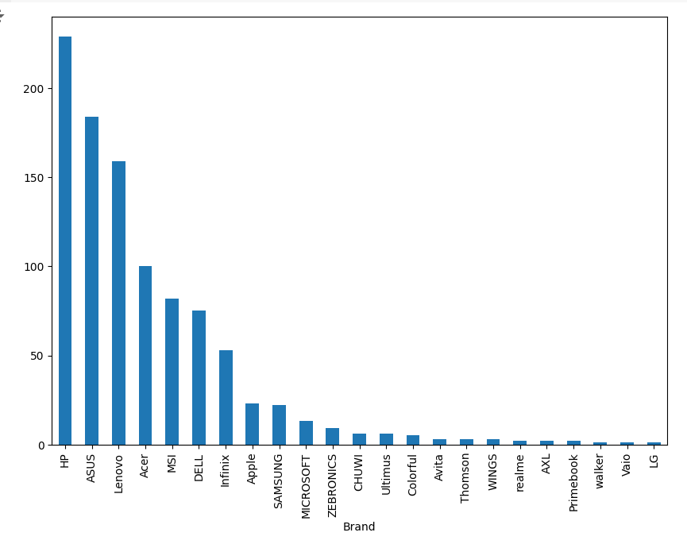

Heatmap
- A heatmap was utilized to graphically show the correlations among the different numerical variables in the dataset. This tool offers a color-coded matrix that indicates the degree and direction of associations between pairs of features.
- When two or more independent variables exhibit strong correlation, a phenomenon known as multicollinearity, it can possibly impact the efficacy of regression models. This image makes it easier to identify multicollinearity.
- Furthermore, Heatmap is used in this project to fine that the dataset have null values or not because it might draw attention to missing data patterns that might need to be fixed before model training, the heatmap is a useful tool for identifying the existence of null values in the dataset.
- All things considered, using a heatmap improves our capacity to decipher and understand intricate relationships found in the data—a critical skill for developing a strong predictive model.
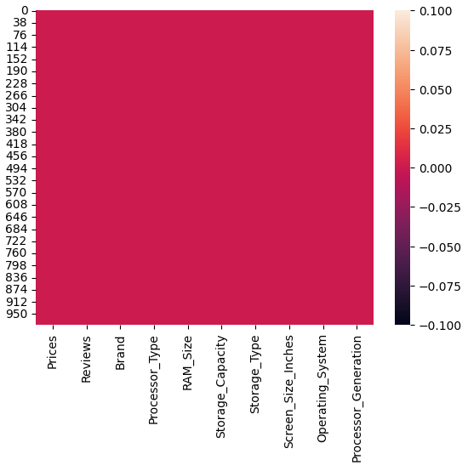

Displot Graph
- A displot (distribution plot), which shows how data points are distributed across a range of values, was used to analyze in detail the distribution of continuous variables, in particular prices.
- We may evaluate important statistical characteristics using this plot, such as skewness, which shows whether the data is symmetrically distributed or slanted toward one end.
- The displot also aids in comprehending the data dispersion, revealing how closely the values cluster around the mean and highlighting the total diversity in the dataset. Crucially, the displot also indicates whether there are any outliers extreme numbers that, if ignored, could have a major impact on the model's performance.

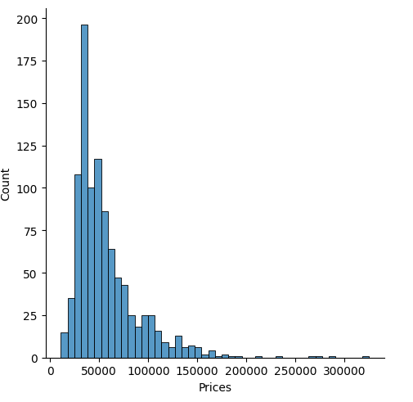

3.3 Design Principles
- Color scheme
- Effective color scheme design is crucial to producing visually appealing and understandable visualizations and user interface elements.
- Choosing color schemes that are accessible to people with color blindness a condition in which an individual lacks the ability to see color is an essential part of developing color schemes.
- Ensuring sufficient contrast between colors is essential for readability and comprehension in addition to accessibility. Users can more quickly and efficiently understand the information presented in the visualizations by being able to distinguish between various aspects because to high contrast.
- For example, contrasting light-colored text with a dark background can improve visibility and make it simpler for consumers to browse through the data being displayed.
- Lastly, considering the general objectives of the data being given, the colors used should be contextual. Depending on the intended audience and message, different datasets could call for different color schemes.
- A data visualization project intended for a younger audience might use bright and dynamic colors to draw attention, but a data visualization project meant to convey financial information might use a more somber color scheme to suggest professionalism and gravity.
- In the end, careful color scheme selection is crucial to producing powerful visualizations that engage people, convey data effectively, and aid in well-informed decision-making.

- Labelling and annotation

- Choosing appropriate font styles and sizes is a crucial component of good labeling. Too-small fonts can cause confusion or aggravation, while too-large fonts can take up too much visual space and take attention away from the actual data.
- It is crucial to select a font size that strikes a balance between readability and attractiveness. Consistent font styles used across the visualizations can also produce a unified aesthetic that strengthens brand identity and promotes user familiarity.

- Layout and interactivity

- Layout and interaction design are crucial components that greatly impact the user experience when creating an interactive graphical user interface. Effective communication between the user and the data is based on a carefully planned layout, which makes sure that important information is presented in a clear, aesthetically pleasing way.
- Following the rules of visual hierarchy, which include highlighting important information with color, size, or positioning, helps consumers quickly and easily understand the key points without becoming overwhelmed.
- The logical flow of information is one of the most important components of a well-designed layout. Reasonably organized content makes it easier for users to navigate the interface and find particular features or data points.
- In addition to improving user experience, this logical layout helps lower cognitive burden so that consumers may concentrate on analyzing the content rather than figuring out how it is arranged. When text and images are aligned properly, the story flows smoothly and users are guided from one piece to the next.
- Buttons and sliders are examples of interactive features that should be thoughtfully positioned throughout the layout. They should be positioned to maximize accessibility and usability while maintaining a visually striking enough contrast to draw in users.
- To further improve user interaction and make it easier for users to understand how to interact with the interface, interactive components should be logically arranged according to their functionality.

- Furthermore, a big part of enhancing the layout's usefulness is the selection of colors, fonts, and styles. Maintaining a consistent color scheme improves the interface's visual attractiveness and makes it easier to distinguish between different parts or functionalities.
- In a similar way, choosing the right font sizes and styles helps improve legibility and guarantee that all text can be seen clearly on a variety of screens and devices.

3.4 Flow chart

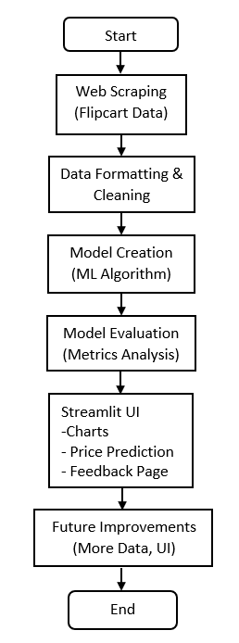

Chapter 4: Visualization Results
4.1 Key Finding
- Major trends or patterns observed

- The main conclusions of the laptop price prediction research provided important new information about the several factors affecting laptop costs. Interestingly, the data showed a strong positive association between RAM_Size and pricing, meaning that laptops with more memory typically fetch higher costs.
- This link highlights RAM's significance as a key component of performance, since users are frequently prepared to spend more for devices that have more memory, which improves multitasking and overall system responsiveness.
- The results also demonstrated how processor generation affects pricing, with newer processing generations being invariably linked to higher prices. This indicates that consumers are influenced to purchase laptops with the newest processors in order to increase efficiency and speed, indicating that technological improvements and performance capabilities are important factors in customer decision-making.
- Furthermore, the storage capacity analysis showed good predictive power, indicating that laptops with larger hard drives or solid-state drives (SSDs) also had higher price points associated with them. This pattern suggests that there is a rising need for devices that can handle large amounts of data storage, which is necessary in a time when digital content and apps require more and more storage.
- All things considered, these major discoveries not only highlight the significance of RAM, processor generation, and storage capacity in influencing laptop costs, but they also offer manufacturers and retailers insightful information about consumer preferences and pricing tactics.
- Stakeholders can better match their product offerings and marketing strategies to satisfy market expectations and maximize profitability by addressing these crucial elements.

- Comparison or anomalies highlighted

- Several significant comparisons and anomalies that offer deeper insights into the market dynamics of laptop pricing were found through thorough data analysis for the laptop price prediction project. The stark price disparity between different brands premium companies like Apple and Dell regularly commanded significantly higher costs compared to their cheaper counterparts was one important result.
- This discrepancy indicates that consumers are frequently more prepared to spend more on brands that they perceive to be prestigious or of good quality, highlighting the significant influence that brand perception has on consumer behavior. According to the statistics, pricing methods are heavily influenced by customer loyalty, marketing tactics, and brand reputation, all of which have an impact on overall sales performance.
- Along with these brand comparisons, the dataset also showed some interesting anomalies, including laptops that were inexpensive but had a large RAM_Size. The accuracy of the pricing data is called into doubt in these circumstances, which may be the consequence of promotional discounts, pricing errors, or the existence of unique models that differ from the usual pricing patterns.
- These anomalies might point to the availability of clearance or refurbished goods, for instance, which might have excellent specs at a lower cost. In addition to alerting us to possible data problems, analyzing these outliers might help us find distinct market niches or consumer behaviors that might deviate from broader trends.

4.2 Visualization Examples
- Include screenshots or links to interactive visualizations


The above is a visualization graph to see the relation between Brand and Prices. As in the graph it is clearly visible that HP brand is having the higher price and LG brand of Laptop having the lowest price. This show that there are some brands of Laptop which are costly even very much costly. As one can see that the brand of laptop whose price is high it is clear that that brand of laptop is used very much. Comparatively the laptop brand having less price is not highly purchased by customers. There can be many reason behind that.
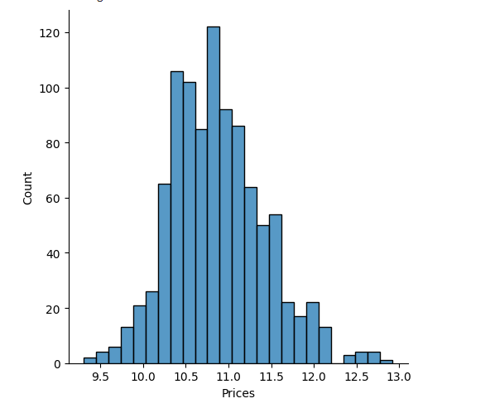
A transformed picture of the price distribution is provided by the displot graph made using the logarithm of prices, which aids in normalizing skewed data and stabilizing variance.
Any underlying patterns or trends that might be hidden in the raw price data are usually highlighted by this transformation, which also typically exposes a more symmetric distribution .With fewer instances of exceptionally low or high costs, the display is likely to peak around the average price, suggesting that the majority of laptops are found in a particular price range. Given that their effect on the distribution is less noticeable after transformation,

4.3 Interpretation
- Implications of the finding

- The results of the study on laptop pricing prediction have important ramifications for consumers and businesses in the IT sector. When buying a laptop, consumers can make well-informed judgments if they are aware of important elements that impact laptop prices, such as RAM Size, Processor Generation, and brand reputation.
- Based on their demands, whether personal or professional, customers can rank the parameters that offer the best value in terms of performance versus cost. These insights give IT organizations a better understanding of the factors that influence consumer behavior when making purchases, which helps them to better target their marketing, pricing, and product offers.
- Businesses can better adapt their products to meet market demands by concentrating on the features that consumers value the most. Furthermore, companies can spot chances for innovation, where changes to product attributes may
- Customers should steer clear of possible dangers of overspending on superfluous specs by prioritizing critical features that provide the best value for their needs.
- The findings from the laptop price prediction project highlight the critical role of product differentiation for manufacturers. By focusing on premium components like higher RAM, newer processor generations, and larger storage capacities, producers can justify higher price points.
- Investing in advanced technology improves performance and user experience, making it easier for companies to charge more for their products. Additionally, leveraging brand reputation through targeted marketing strategies can further enhance perceived value, leading to greater consumer willingness to pay premium prices.
- These insights suggest that by prioritizing both technical superiority and brand image, manufacturers can better position themselves in the competitive market, aligning with customer expectations and maximizing profitability.
- Furthermore, keeping high-quality items and satisfied customers is crucial, as evidenced by the impact that customer evaluations and ratings have on pricing strategies.

- Recommendations based on the results

- Setting greater RAM capacities and more recent CPU generations as top priorities for laptop purchases is highly advised, according to the results of the laptop price prediction project. It has been demonstrated that these criteria greatly improve performance, especially with regard to managing multitasking, executing intricate programs, and facilitating high-speed operations.
- Better energy management, faster data processing, and enhanced efficiency are guaranteed by a more modern processor generation, while a larger RAM capacity enables more seamless performance—even when several programs are running at once.
- These elements should be taken into consideration by consumers seeking improved performance and long-term value because they have a significant impact on the device's longevity and overall user experience. Moreover, spending money on these features improves performance right away and future-proofs the laptop, making sure it can handle changes in software requirements.
- Customers are encouraged to think about brand reputation while making selections since premium brands frequently provide benefits that go beyond technical details. More build quality means better longevity and durability for laptops from well-known companies like Apple, Dell, or HP.
- Premium brands are also recognized for providing better after-sales care, warranty assistance, and access to authorized service centers, among other high-quality customer services. By enhancing the ownership experience, lowering the risk of technical problems, and providing peace of mind, these elements help to justify the premium brands' higher prices.
- Although less well-known or inexpensive brands could be less expensive up front, investing in a recognized brand might save money in the long run because of fewer repairs and a longer lifespan. Customers should thus consider both technical parameters and brand repute when evaluating total value.
- customers are advised to study reviews and ratings in order to assess the product's performance in the real world and user happiness.
- In order to draw in price-conscious customers, producers must concentrate on developing products that include high-performing parts like sophisticated processors and lots of RAM. Regular market research is also advised in order to recognize changing customer preferences and modify product offerings appropriately.
- In order to gain potential customers' trust, Producer should think about improving their web presence through marketing techniques that showcase product characteristics and user testimonials.

4.4 Gantt Chart

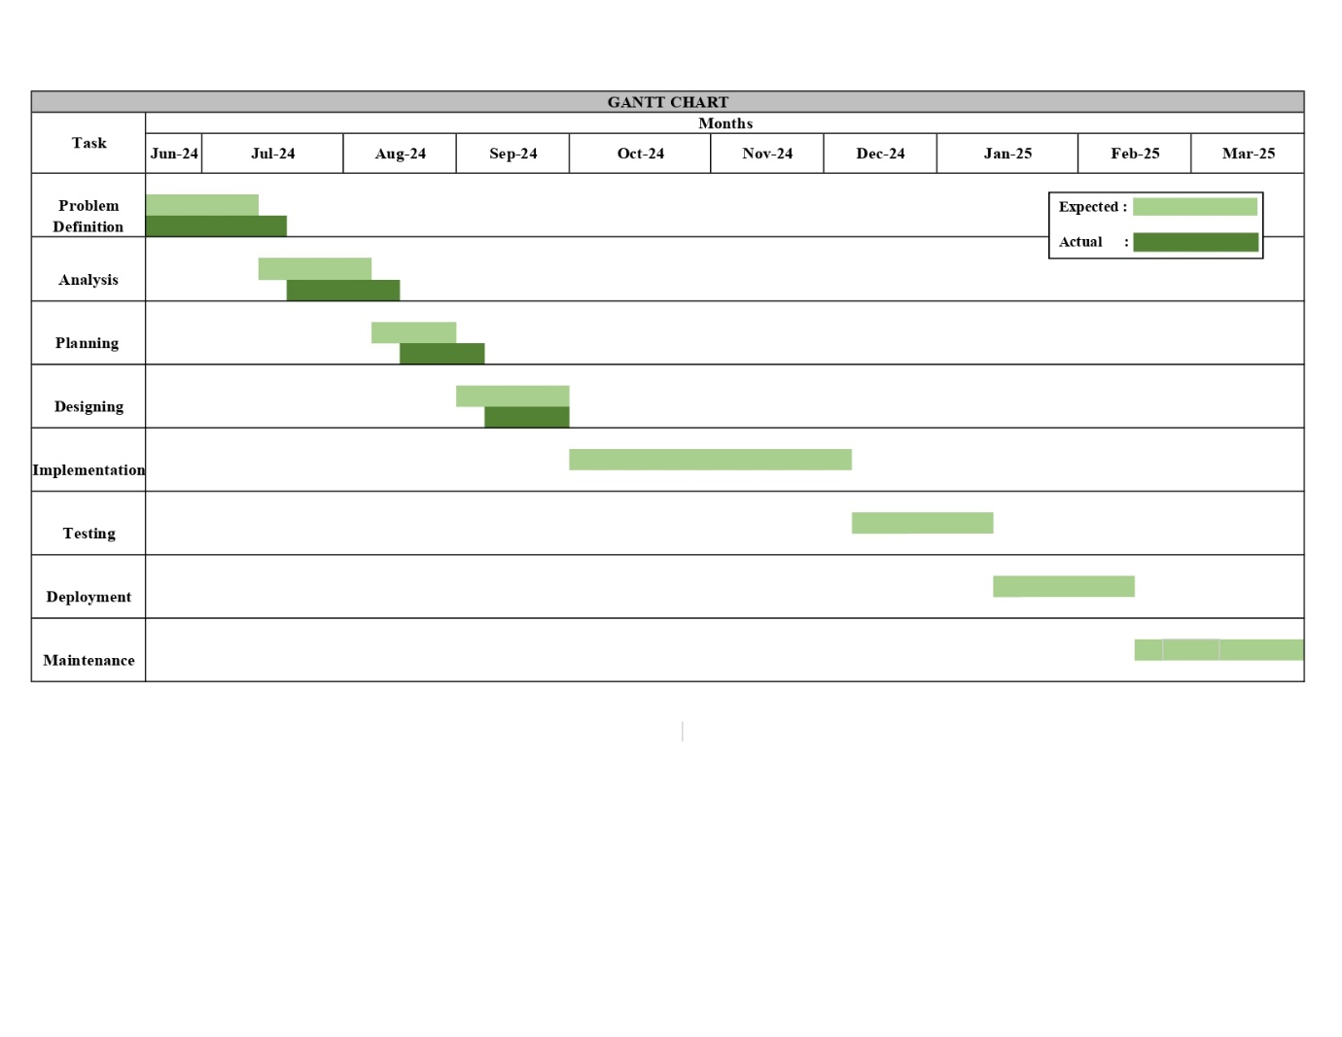

Chapter 5: Challenges and Limitations
5.1 Challenges Faced
- Data quality issues
- Building an effective laptop price prediction model requires high-quality data, however during the research, a number of data quality problems were found. Missing data in important properties like Operating System, Processor Type, and Storage Capacity were one of the main problems. Model performance may be greatly impacted by missing data as incomplete records might result in erroneous training or biased predictions. To solve this problem, a variety of imputation strategies were used, such as using the most common category or mean values to fill in missing values.
- Inconsistent data formatting, especially in category columns, presented another difficulty. To prevent problems during encoding, for instance, the Storage Capacity column needs to be standardized because it had variants such as "256 GB", "256GB", and "256 gb". Likewise, there were several methods for Processor Type to

- Another major worry was pricing anomalies for laptops. Extremely high or low costs were included in the dataset; this might have been caused by special discounts, data entry mistakes, or premium models. The learning process of the model may be distorted by these outliers, producing predictions that are less trustworthy.

- Additionally, there was a class imbalance in the dataset, particularly in several categorical characteristics. It was challenging for the model to correctly understand the price trends of some brands and processor kinds since they had a lot less data points than others. In order to guarantee equitable representation of all categories, methods like oversampling, undersampling, or weight modifications were taken into consideration.
- Finally, because laptop costs fluctuate based on availability, market trends, and discounts, real-time pricing variations presented a hurdle. Older price data may not accurately reflect current market circumstances since the dataset only included prices at a certain moment in time. To increase prediction accuracy over time, it was determined that regular dataset updates and model retraining were essential.

- Technical difficulties
- A number of technological difficulties arose during the creation of the Laptop Price Prediction model and its Streamlit-based GUI. Effectively managing categorical data was one of the main problems. Brand, Processor Type, Storage Capacity, and Operating System were among the several categorical characteristics in the dataset that needed to be encoded before they could be incorporated into the model.

- The One-Hot Encoding approach first increased the dimensionality of features, which resulted in computational inefficiencies. To solve this problem and preserve model accuracy, ordinal encoding and handling unknown categories in the test data were later used.
- Preprocessing and cleansing the data presented another major obstacle. Inconsistencies in the Flipkart-extracted dataset included duplicate records, missing values, and irregular formatting in category fields. To address these problems, a great deal of preprocessing was needed.

- Issues with handling several pages for price prediction, data visualization, and storing predictions to a CSV file were also brought about by the deployment of the Streamlit GUI. Because Streamlit's default behavior reloads the whole app with each interaction, switching between pages was initially difficult.

- This was fixed to provide a smooth experience by storing user inputs and outcomes in session states. Additionally, modifying layouts and incorporating CSS changes to enhance readability and design were necessary to style the GUI in a way that was more user-friendly.
- Uploading the project on github is another technical difficulty.managing a repository using git init, git push command and etc.

- Last but not least, one of the main technological challenges was improving model performance. Because laptop prices are non-linear, the initial use of a basic linear regression model produced forecasts that were not correct. Polynomial Regression and Decision Trees were investigated to enhance performance, which resulted in increased accuracy.

- In order to eliminate superfluous features that can add noise to the model, feature selection techniques were also used. To optimize hyperparameters and enhance generalization on unseen data, ongoing testing and validation were required.
- Nevertheless, every technological obstacle offered a chance to improve the user interface, hone the model, and boost project efficiency as a whole.

- Time constraints

- The development of the Laptop Price Prediction model and its Streamlit-based graphical user interface was significantly hampered by time limitations. Within a constrained period, the project needed to go through many stages, including data gathering, preprocessing, model building, GUI construction, and deployment.

- Since each step took a lot of time, it was essential to balance them well to guarantee a precise and working system. Effectively dividing time between developing, debugging, and testing presented a significant difficulty since machine learning operations are complicated.
- Preprocessing and cleansing the data was one of the most time-consuming activities. It took a lot of work to clean and normalize the raw dataset because it included outliers, missing numbers, and inconsistent formatting.

- It needed more effort to handle categorical variables, properly encode them, and make sure that test data's unknown categories were taken into consideration.

- Time constraints also affected model selection and training. A straightforward linear regression model was first evaluated, but due to its subpar results, more sophisticated algorithms including decision trees and polynomial regression were investigated. It took several iterations to optimize the model's predictions, validate it, and adjust hyperparameters.

- The technique was time-consuming since it required evaluating various feature combinations during each model training session, which limited the number of experimental runs that could be completed in the allotted period.

- More time-related difficulties arose during the creation of the Streamlit GUI. It took careful planning and effective code to integrate several pages for price prediction, charting, and prediction saving.

- Furthermore, rigorous debugging and adjustments were required to handle session states, develop a seamless user experience, and guarantee a smooth transition between various capabilities. It also took longer than expected to customize the GUI's layout and improve its look since it took several tries to get a responsive and aesthetically pleasing interface.

5.2 Limitations
- Constraints of the data

- Managing the several constraints in the dataset was one of the main obstacles in the Laptop Price Prediction project. Before being utilized to train the model, the dataset's numerical and categorical variables needed to undergo a thorough preparation step.

- Since several of the categorical columns including Brand, Processor Type, Storage Capacity, and Operating System were in text format, they needed to be converted into numerical values using encoding techniques like Ordinal Encoding or One-Hot Encoding. Nevertheless, extra data cleaning was necessary because some categorical variables had inconsistent formatting, such as multiple spellings for the same brand or varied ways of describing storage volumes.

- The dataset's missing values were yet another important limitation. Null values were present in some columns, which could have a detrimental effect on model performance if not handled appropriately. Imputation methods, such as substituting the mean, median, or mode for missing values, were employed to remedy this. However, because the optimal imputation technique relied on the data distribution, it was especially difficult to fill in missing values in categorical columns.

- In certain instances, removing rows with missing values was taken into consideration; nonetheless, this resulted in a smaller dataset, which might have an impact on the model's capacity to learn.

- Another problem with the dataset was data imbalance. The model may be skewed toward the more common categories since some brands, processor types, or operating systems have much less data points than others.

- For less popular laptop combinations, this imbalance could result in erroneous projections. During model training, methods including oversampling, undersampling, or allocating weights to various categories were taken into consideration in order to lessen this.
- Laptop price outliers presented another difficulty as they might distort the forecasts. Some computers were much more or less expensive than the rest, which might have been caused by mistakes in data collecting, premium features, or brand reputation. It was necessary to carefully analyze these outliers

- Data preparation, feature engineering, addressing missing values, controlling outliers, and meticulous model pipeline design were all necessary to overcome these limitations. Notwithstanding these difficulties, the dataset was improved to guarantee that it offered insightful information and precise laptop price forecasts.

- Potential biases

- A number of variables in the dataset may cause bias in the laptop price prediction model. The uneven portrayal of brands and specs is one of the main causes of prejudice.

- The model could undervalue the costs of less popular configurations while favoring laptops with a certain brand or feature (such as SSD storage over HDD or Intel CPUs over AMD) if the dataset has more of such laptops. For laptops that are underrepresented in the training data, this may result in erroneous forecasts.
- Price differences brought on by seasonal sales and promotions are yet another possible source of prejudice. The dataset could contain pricing impacted by sales events, including holiday discounts or clearance sales, because it is based on historical data from Flipkart. If the majority.

- Biases that are strange to a market or region may also exist. The model may not take into consideration price variations between international marketplaces if the dataset is just drawn from a single geographic area or e-commerce site.

- Laptop prices are influenced by a number of factors, including local demand, import taxes, and customs. However, if these factors are not included in the dataset, the model may produce biased predictions that are not applicable in other countries.
- Finally, bias may be introduced by past pricing trends. The model could pick up out-of-date price trends that don't represent the current market if the dataset contains both newer and older laptop models.

- Price reductions for earlier models are sometimes caused by the quick development of technology; if this trend is not appropriately taken into consideration, the model may overestimate or

- Assumptions made

- While creating the Laptop Price Prediction model, a number of presumptions were established to guarantee an organized method for processing data and training the model.

- The initial assumption is that price variation is largely influenced by all laptop specs. Brand, CPU type, RAM size, storage capacity, screen size, and operating system are all taken into account by the model as key factors that affect pricing.

- Although these elements have an impact on price, the dataset does not specifically contain other variables like build quality, graphics card, display type, and other features (such as touchscreen or battery life). Their influence is thought to be either negligible or indirectly represented by related qualities.

- The dataset is also thought to be reflective of the laptop market as a whole. Models that are available on other e-commerce platforms or offline markets might not be included in the data because it was gathered from Flipkart.

- The model makes the assumption that, despite any regional differences in price, promotions, and supply chain elements, the pricing patterns seen in Flipkart's dataset apply to a larger market.

- The model also makes the assumption that the correlations between pricing and non-numeric variables are adequately captured by category encoding. Assuming that these representations maintain the price effect of each category, encoding techniques were used to change features such as processor type and brand.

- This may not, however, adequately convey the nuanced interactions between many brands and their disparate degrees of market demand or customer perception.

- Lastly, it is assumed that there are no notable flaws or inconsistencies in the cleaned and preprocessed dataset. With the belief that these actions would successfully enhance data quality, data preparation included handling missing values, converting category characteristics, and normalizing numerical data.

- The model's predictions may be impacted by any remaining dataset flaws, such as inaccurate specifications or incorrectly categorized items, but these are thought to be negligible.

Chapter 6: Future Work

6.1 Recommendations
- Additional data that could enhance the analysis

- Even while the Laptop Price Prediction model did well with the dataset that was given, adding more data might greatly increase its precision and insights.

- The important factors that influence customer preferences include laptop weight and battery life. Particularly in the ultrabook market, lightweight computers with extended battery life are sometimes more expensive. By adding these elements, the algorithm would be able to identify more subtle price patterns, improving forecasts for various user categories, including professionals, gamers, and students.

- Including graphics card specs might improve the model much further. Dedicated GPUs are frequently included in gaming and high-performance laptops, which has a big financial impact. As of right now, the dataset might not accurately reflect how various GPU models affect prices. Using this information might make it easier to distinguish between laptops intended for gaming or professional content creation and those aimed at casual users.

- Details about the guarantee and the repute of the brand would be another beneficial addition. Because of their reputation for quality and customer service, certain brands are more expensive. Furthermore, laptops with premium support services or extended warranty options are sometimes more expensive. The model's capacity to defend price changes may be strengthened if these features are included in the dataset.

- Stock levels and availability also affect pricing changes. The price of a particular laptop model may rise when it becomes scarce owing to great demand. On the other hand, prices may decrease when merchants give discounts to get rid of outdated stock. More in-depth understanding of market-driven price behavior may be obtained by monitoring stock availability alongside pricing fluctuations.

- Last but not least, adding regional pricing variances would help the model be more marketable. Due to store tactics, local demand, and import taxes, laptop costs might differ depending on where you live. The model would be able to produce more accurate predictions for users in various geographic regions if it included region-specific price data. The study might be greatly improved by incorporating these more data points, which would make the model more thorough and helpful for price prediction and suggestion.

- Possible improvements to the visualizations

- Although the primary insights are adequately presented by the current visualizations, a few tweaks might increase their impact and clarity. Adding interactive charts with libraries like Altair or Plotly is one potential improvement. By enabling visitors to zoom in on certain features, select categories, and hover over data points, interactive visualizations would enhance the analysis's readability and educational value.
- Using color gradients and themes to more easily distinguish various pricing ranges may be another enhancement. A heatmap depicting average costs for various brands and storage capacities, for instance, can more successfully draw attention to patterns. Additionally, consistent and eye-catching color schemes would enhance reading and facilitate the interpretation of information.
- Clarity may be increased by improving the annotations and labeling on bar charts. Bar charts now show broad patterns, but by including specific data above the bars.

- The study would be more interesting if the price-related charts included trend lines and moving averages. Adding trend indicators might assist customers comprehend larger market trends by showing price variations over time or by different laptop characteristics, as opposed to just raw price distributions.
Adding stacked and grouped bar charts for multi-category comparisons might be an improvement. Users may examine how several factors affect cost at the same time, for instance, by comparing the average laptop price across manufacturers and operating systems using a grouped bar chart. A more thorough comparative analysis would result from this.

- Price distribution analysis may be enhanced by combining bar charts with box plots or violin plots. These plots would provide greater insights into pricing patterns by illuminating price spread, highlighting outliers, and illustrating variance across several categories. This would be particularly helpful in determining whether there is a greater price variance for particular laptop manufacturers or combinations.
- Finally, accessibility would be improved by adding succinct, unambiguous explanations to chart names and captions. By putting these changes into practice, the visualizations would become more user-friendly, informative, and intuitive, giving a clearer picture of market behavior and pricing patterns.

6.2 Next Steps
- Future analyses

- Future research can examine time-based pricing patterns to improve the Laptop pricing Prediction model even further. Deeper insights might be gained by examining how laptop costs fluctuate over time as a result of new model launches, seasonal specials, or technology developments. Users may be able to make better selections about what to buy if past pricing information is taken into account and future patterns are anticipated.
- Predicting the prices of future laptop models is another important subject for further research. The algorithm may predict the anticipated cost of forthcoming releases by using the specs of previously released laptops and comparing them to historical patterns. Those who want to predict prices before making a purchase might find this very helpful.
- Customer review sentiment analysis may provide further information about pricing choices. Recognizing the relationship between laptop specs and cost and customer satisfaction.

- An further possible enhancement would be to broaden the study to include the cost of reconditioned or used laptops. Since many buyers buy old laptops, estimating resale prices may be possible by looking at depreciation rates according to brand, model, and age. This might offer helpful suggestions for consumers weighing their alternatives for new and old laptops.

- Price differences by geography and market might be the subject of future research. Since taxes, shipping charges, and brand availability all affect laptop prices, examining these regional variances would help the model become more flexible. Users in particular places may benefit from better pricing forecasts if regional data is integrated.

- Feature significance ranking with machine learning methods is another intriguing field of study. We might identify the laptop parameters that most significantly affect price by using models such as SHAP (Shapley Additive Explanations) or feature significance plots using tree-based models. Deeper understanding of how various factors affect laptop prices might result from this.

- Finally, using forecasting methods to anticipate future patterns in laptop prices may improve the project's long-term usefulness. We might anticipate how prices would vary in response to market trends using techniques like LSTM models or time-series forecasting with ARIMA, which would help users better plan their purchases. The project may develop into a thorough tool for trend analysis and price recommendations by including these next analyses.

Chapter 7: References

7.1 Data Sources
- The main source of data for this project is Flipkart, from which web scraping techniques are used to gather comprehensive laptop specifications and pricing. Important characteristics that affect laptop cost are included in the dataset, including brand, CPU type, RAM size, storage capacity, screen size, operating system, and processor generation.

- Having this information is essential to creating a trustworthy price prediction model. Initial formatting problems, missing numbers, and inconsistencies in the raw scraped data were fixed by preprocessing and data cleaning procedures.
.
- Prior to model training, ensuring data quality and relevance was crucial to enhancing prediction performance. The dataset was organized for improved analysis with the use of feature engineering, missing value management, and format standardization.
- The cleansed dataset gave machine learning algorithms a solid starting point for efficient laptop price prediction training. This dataset is used to teach the model price patterns and feature connections.

- The comprehension of price patterns was further improved via exploratory data analysis and summary statistics. Additional external sources, such manufacturer websites and consumer evaluations, may be incorporated into future project iterations in order to enhance the dataset.

- By adding real-world changes and customer insights, this would aid in improving the model's predictions. Even more dynamic and precise laptop price estimates may result from the integration of additional sources and structured data.

7.2 Literature
- The known data science and machine learning approaches for price prediction form the foundation of this study.

- Regression model literature, especially Polynomial Regression, Ridge algorithm which effectively captures non-linear correlations between laptop attributes and costs, is one of the main sources cited.

- Furthermore, preprocessing methods like feature scaling and One-Hot Encoding are based on accepted data science approaches.

- To understand the elements impacting laptop prices, a variety of research and publications on customer preferences, hardware specs, and laptop pricing patterns were taken into consideration. Data collecting also heavily relied on research on online scraping methods, namely requests and BeautifulSoup.

7.3 Tools and Software
Python was the main programming language used in this project, coupled with a number of frameworks and packages for data processing, model construction, and visualization.

The machine learning model was developed and tested using Google Colab further the model is copied in the vs code and project files were organized and data was cleaned using Visual Studio Code.
Pandas and NumPy were used to handle the data, After exploring various model the final model I have used is Ridge model.
The interactive GUI was created using Streamlit, while the visualization was done using Matplotlib and Seaborn. For version control and project deployment, Git and GitHub were utilized, guaranteeing effective code management and teamwork.

Chapter 8: Appendices

8.1 Appendix A: Data Tables
- Raw scraped data, preprocessed data, and extra computed values for model training and assessment make up the dataset's three primary phases.Flipkart is the source of the raw scraped dataset, which has inconsistent formats, duplicate entries, and missing variables.
- After addressing missing values, standardizing formats, and guaranteeing consistent data types for machine learning, the preprocessed dataset is produced.Computed fields such as frequency distributions, feature-based aggregations, and average laptop costs by category are examples of additional calculated data.
- Brand, CPU type, RAM size, storage capacity, screen size, operating system, processor generation, and price are important factors that affect laptop cost.

- The brand influences the price range by representing manufacturers such as Dell, HP, or Lenovo.The type of CPU (such as AMD Ryzen 7 or Intel i5) has a significant impact on both price and performance.
- Speed and multitasking are affected by RAM size, but data efficiency is determined by storage capacity (HDD/SSD).Usability is impacted by screen size, while compatibility is influenced by operating system (Windows, macOS, Linux).Improvements in CPU performance are reflected in processor generation, which affects efficiency and cost.

- The frequency distributions of category variables, such as processor kinds and brands, are highlighted by summary statistics.

- An understanding of how requirements impact cost and market trends may be gained from average pricing per category.For comparison study, the dataset displays the leading laptop brands according to availability and price.

8.2 Appendix B: Code

- The whole Python code utilized for the various project phases is included in this section, including:
Web Scraping Code: Using BeautifulSoup and requests, laptop info is extracted from Flipkart.
- Data Preprocessing Code: NumPy and pandas are used to clean and convert data format.
Model Development Code: Using scikit-learn and feature encoding approaches to implement Ridge model.
- Visualization Code: Using Matplotlib and Seaborn to create bar charts and other visualizations.
- Streamlit Application Code: Developing a graphical user interface (GUI) for predicting laptop prices interactive user input, created a page to show charts and a page to save the specification given by the user.

8.3 Appendix C: Glossary

- This section clarifies technical ideas and techniques by defining essential phrases used throughout the project.

- Web scraping is a method for gathering information from webpages. In this project, Flipkart laptop pricing data was scraped using BeautifulSoup and requests.

- Ridge model:Better price prediction is made possible by Ridge model.

- One-Hot Encoding: A technique for efficiently transforming category input into numerical representation for machine learning algorithms.

- Normalizing numerical quantities to enhance model performance is known as feature scaling.

- Machine Learning Pipeline: A series of data processing operations that guarantee an effective workflow, such as preprocessing, model training, and assessment.
Streamlit is a Python framework for making.

